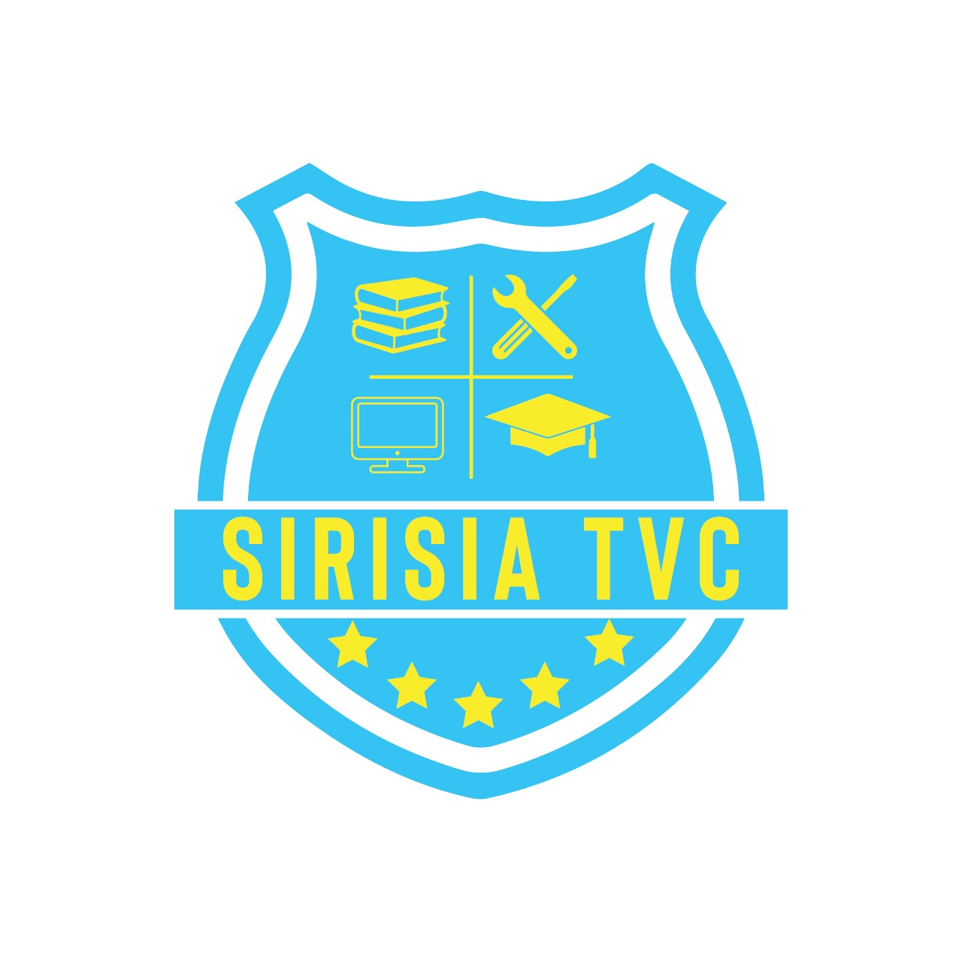
MINISTRY OF EDUCATION

STATE DEPARTMENT OF VOCATIONAL & TECHNICAL TRAINING

SIRISIA TECHNICAL AND VOCATIONAL COLLEGE

Technology for better life

P. O. BOX 77 – 50208, SIRISIA (KENYA)

Cell Phone: 0722881543/0703547217

Email: Info@sirisiatvc.ac.ke or sirisiavocational@gmail.com.com

COURSES OFFERED

S/NO | COURSES | MINIMUM | CLUSTER | DURATION | INTAKE | EXAM BODY
 |  | REQUIREMENTS
 | ELECTRICAL AND ELECTRONICS ENGINEERING DEPARTMENT
1. | Diploma in Electrical & | C- (Minus) | Nil | 3yrs | Jan/May/Sep | KNEC
 | Electronics (Power Option)
2. | Certificate in Electrical & | D (Plain) | Nil | 2yrs | Jan/May/Sep | KNEC
 | Electronics Engineering
3. | Artisan in Electrical & | E to D- / KCPE | Nil | 1yr | Jan/May/Sep | KNEC
 | Electronics
4. | Electrical Installation Level 6 | C- (Minus) / | Nil | 2½yrs | Jan/May/Sep | TVET/CDACC
 |  | Level 5
5. | Electrical Installation Level 5 | D+ / Level 4 | Nil | 2yrs | Jan/May/Sep | TVET/CDACC
 | BUILDING AND CIVIL ENGINEERING DEPARTMENT
6. | Diploma in Building | C- (Minus) | Nil | 3yrs | Jan/May/Sep | KNEC
 | Technology
7. | Diploma in Civil Engineering | C- (Minus) | Nil | 3yrs | Jan/May/Sep | KNEC
8. | Diploma in Architecture | C- (Minus) | Nil | 3yrs | Jan/May/Sep | KNEC
9. | Craft in General Building & | D (Plain) | Nil | 2yrs | Jan/May/Sep | KNEC
 | Construction
10 | Certificate in Plumbing | D (Plain) | Nil | 2yrs | Jan/May/Sep | KNEC
11 | Artisan in Plumbing | D- / KCPE | Nil | 1yr | Jan/May/Sep | KNEC
12 | Artisan in Masonry | D- / KCPE | Nil | 1yr | Jan/May/Sep | KNEC
 |  | LIBERAL STUDIES DEPARTMENT
13 | Certificate in Social Work & | D (Plain) | Nil | 2yrs | Jan/May/Sep | KNEC
 | Community Development
14 | Diploma in Social Work & | C- (Minus) | Nil | 3yrs | Jan/May/Sep | KNEC
 | Community Development


All Correspondence should be addressed to the Principal

HOSPITALITY AND INSTITUTIONAL MANAGEMENT DEPARTMENT

15 | Artisan in Garment Making | E to D- / KCPE | Nil | 1yr | Jan/May/Sep | KNEC
16 | Certificate in Hair Dressing | D (Plain) | Nil | 2yrs | Jan/May/Sep | KNEC
17 | Certificate in Beauty Therapy | D (Plain) | Nil | 2yrs | Jan/May/Sep | KNEC
18 | Certificate in Fashion Design | D (Plain) | Nil | 2yrs | Jan/May/Sep | KNEC

- Garment making Technology
19 | Diploma in Fashion Design & | C- (Minus) | Nil | 3yrs | Jan/May/Sep | KNEC
 | Garment making Technology
20 | Artisan in Food & Beverage | D- (Minus) | Nil | 1yr | Jan/May/Sep | KNEC
21 | Certificate in Food & | D (Plain) | Nil | 2yrs | Jan/May/Sep | KNEC
 | Beverage
22 | Diploma in Food & Beverage | C- (Minus) | Nil | 3yrs | Jan/May/Sep | KNEC
23 | Certificate in Catering & | D (Plain) | Nil | 2yrs | Jan/May/Sep | KNEC
 | Accommodation
24 | Diploma in Catering & | C- (Minus) | Nil | 3yrs | Jan/May/Sep | KNEC
 | Accommodation
 | INFORMATION AND COMMUNICATION TECHNOLOGY DEPARTMENT
25 | Diploma in ICT | C- (Minus) | Nil | 3yrs | Jan/May/Sep | KNEC
26 | Diploma in Information | C- (Minus) | Nil | 3yrs | Jan/May/Sep | KNEC
 | Studies
27 | Certificate in ICT | D+ (Plus) | Nil | 2yrs | Jan/May/Sep | KNEC
28 | Certificate in Information | D+ (Plus) | Nil | 2yrs | Jan/May/Sep | KNEC
 | Studies
29 | ICT Level 4 Technician | D- (Minus) | Nil | 6 months | Jan/May/Sep | TVET/CDACC
30 | ICT Level 5 Technician | D+ / Level 4 | Nil | 1yr | Jan/May/Sep | TVET/CDACC
 | MECHANICAL ENGINEERING DEPARTMENT
31 | Artisan in Automotive | D- (Minus) | Nil | 1yr | Jan/May/Sep | KNEC
32 | Artisan in Welding & | D- (Minus) | Nil | 1yr | Jan/May/Sep | KNEC
 | Fabrication
33 | Craft in Automotive | D+ (Plus) | Nil | 2yrs | Jan/May/Sep | KNEC
 | Engineering
34 | Diploma in Automotive | C- (Minus) | Pass in | 3yrs | Jan/May/Sep | KNEC
 | Engineering |  | Maths &
 |  |  | Physics


All Correspondence should be addressed to the Principal


AGRICULTURE AND ENVIRONMENTAL STUDIES DEPARTMENT

35 | Diploma in General | C- (Minus) | Nil | 3yrs | Jan/May/Sep | KNEC
 | Agriculture
36 | Diploma in Entrepreneurial | C- (Minus) | Nil | 3yrs | Jan/May/Sep | KNEC
 | Agriculture
37 | Certificate in General | D+ (Plus) | Nil | 2yrs | Jan/May/Sep | KNEC
 | Agriculture
38 | Artisan in General | D- (Minus) | Nil | 1yr | Jan/May/Sep | KNEC
 | Agriculture
39 | Dairy Farming Management | D+ (Plus) | Nil | 2yrs | Jan/May/Sep | TVET/CDACC
 | Level 5
40 | Dairy Farming Management | C - (Minus)/ Level | Nil | 2½yrs | Jan/May/Sep | TVET/CDACC
 | Level 6 | 5
 |  | APPLIED SCIENCES DEPARTMENT
41 | Diploma in Applied Biology | C- (Minus) | Bio D+ | 3yrs | Jan/May/Sep | KNEC
42 | Diploma in Food Processing | C- (Minus) | Nil | 3yrs | Jan/May/Sep | KNEC
 | & Preservation Technology
43
 | Certificate in Food Processing | D (Plain) | Nil | 2yrs | Jan/May/Sep | KNEC
 | & Preservation Technology

All Correspondence should be addressed to the Principal

 | BUSINESS STUDIES DEPARTMENT
44 | Certificate in Business | D (Plain) | Nil | 2yrs | Jan/May/Sep | KNEC
 | Management
45 | Certificate in Cooperative | D (Plain) | Nil | 2yrs | Jan/May/Sep | KNEC
 | Management
46 | Certificate in Human | D (Plain) | Nil | 2yrs | Jan/May/Sep | KNEC
 | Resource Management
47 | Certificate in Banking & | D (Plain) | Nil | 2yrs | Jan/May/Sep | KNEC
 | Finance
48 | Certificate in Supply Chain | D (Plain) | Nil | 2yrs | Jan/May/Sep | KNEC
 | Management
49 | Certificate in Project | D (Plain) | Nil | 2yrs | Jan/May/Sep | KNEC
 | Management
50 | Artisan in Store Keeping | D- (Minus) | Nil | 1yr | Jan/May/Sep | KNEC
51 | Diploma in Project | C- (Minus) | Nil | 3yrs | Jan/May/Sep | KNEC
 | Management
52 | Diploma in Computerized | C- (Minus) | Nil | 3yrs | Jan/May/Sep | KNEC
 | Secretarial
53 | Computerized Secretarial | D (Plain) | Nil | 2yrs | Jan/May/Sep | KNEC
 | (Single & Group)
54 | Diploma in Accountancy | C- (Minus) | Nil | 3yrs | Jan/May/Sep | KNEC
55 | Diploma in Business | C- (Minus) | Nil | 3yrs | Jan/May/Sep | KNEC
 | Management
56 | Diploma in Cooperative | C- (Minus) | Nil | 3yrs | Jan/May/Sep | KNEC
 | Management
57 | Diploma in Banking & | C- (Minus) | Nil | 3yrs | Jan/May/Sep | KNEC
 | Finance
58 | Diploma in Human Resource | C- (Minus) | Nil | 3yrs | Jan/May/Sep | KNEC
 | Management
59 | Diploma in Supply Chain | C- (Minus) | Nil | 3yrs | Jan/May/Sep | KNEC
 | Management


NOTE:

Please apply to the Principal for studying the Course you have chosen

OR

Personally visit Sirisia Technical and Vocational College for further clarification.

For any enquiries about admission, please contact Customer Care Desk during office hours through:

0703547217 or 0758345820.

Technology for better life

All Correspondence should be addressed to the Principal

